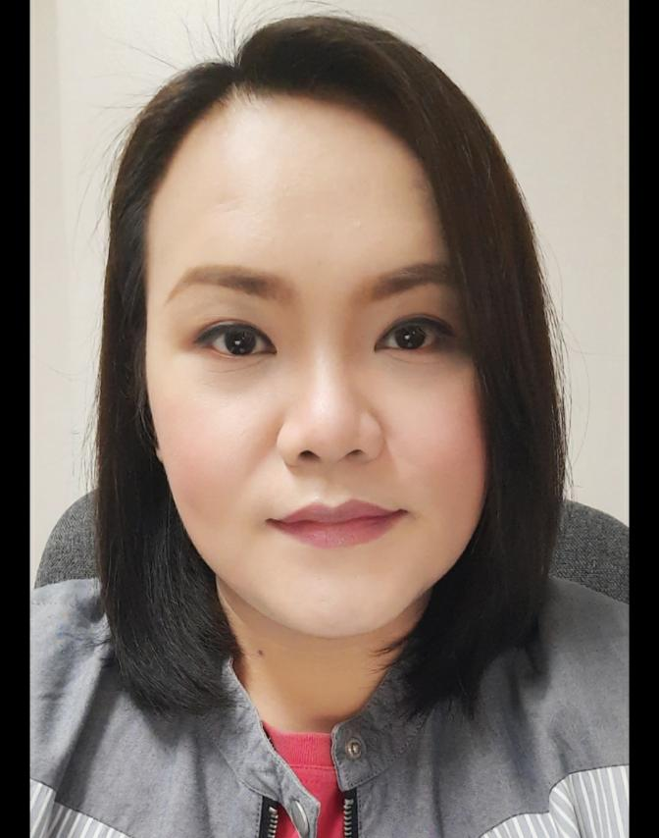

**Laila Esusan Laquindanum**

No. 28 V. Gonzales St. Krus Na Ligas

Diliman, Quezon City 1101

Mobile No.: 0929-1965098

Email Address: llaquindanum83@gmail.com

**EMPLOYMENT HISTORY**

**F&B Manager** October 7, 2020 to Present

F&B Supervisor August 15, 2019 to October 6, 2020

Hotel Supervisor (Quezon Ave. & Timog) December 3, 2018

Hotel Sogo Group

Global Comfort Group Inc.

**Regional Manager** March 3, 2018 to October 31, 2018

Mineski Infinity Franchise Corp.

**Restaurant Manager** May 19, 2016 to February 15, 2018

Kuya J Restaurant, SM Sta. Mesa

**Dining Supervisor**  March 3, 2014 – May 15, 2016

Mesa Filipino Moderne, Tomas Morato

Northside Table Inc.

**Event Coordinator (Freelance)** December 2012 to March 2014

Solutions Events, Blissfully Hitch Event

Styled Celebrations

**F&B Manager / Banquet Manager** March 3, 2012 to December 5, 2012

Hotel San Marco

General Santos City

**Banquet Sales Executive**  February 28, 2010 to February 10, 2011

Hizon’s Restaurant and Catering Services

**OIC- Shift Manager**  July 19, 2015 to October 2, 2009

Cashier Trainer (regular) February 11, 2015 to July 18, 2015

Cashier / Ordertaker August 30. 2014 to January 30, 2015

Yellowcab Food Corp.

**EDUCATIONAL BACKGROUND**

**BACHELOR IN HOTEL AND RESTAURANT MANAGEMENT**

SY 2000 – 2004

**POLYTECHNIC UNIVERSITY OF THE PHILIPPINES**

**STA. MESA**

**PERSONAL INFORMATION**

Age: 34 years old Religion: Catholic

Birthdate: November 25, 1983 Birth Place: Manila

Citizenship: Filipino Civil Status: Single

Parents: Violeta E. Laquindanum Occupation: Retired Midwife

Eduardo D. Laquindanum Occupation: Deceased

**RELATED TRAININGS**

Human Relation, Dale Carnegie Course July 12, 2010

Creative Banquet Selling, Guthrie Jensen Course July 29, 2010

Apprenticeship – 100 hours November 23 to 25, 2003

Super Ferry 12 (Cebu-Manila)

Accounting / Housekeeping March 25, 2003 to May 25, 2003

OJT- Mandarin Oriental Manila

On the Job Training January 2 to February 16, 2002

Hard Rock Café Makati

**CHARACTER REFERENCE**

Chef Ben Bernardo Joy E. Icalabis

Sous Chef / Consultant L&D

The Terrace, Resorts World Manilla Kuya J Restaurant

0917-5499710 0995-3017636

I hereby certify that the above statements were true and correct to the best of my knowledge.

**Laila E. Laquindanum**